4.1 E.R-Diagram with one case study:

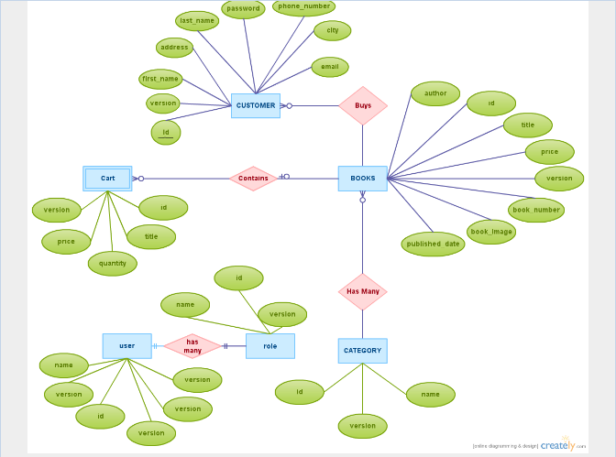

4.2 Design:

Database design is the process of producing a detailed [data model](https://en.wikipedia.org/wiki/Data_model) of a [database](https://en.wikipedia.org/wiki/Database). This [logical data model](https://en.wikipedia.org/wiki/Logical_data_model) contains all the needed logical and physical design choices and physical storage parameters needed to generate a design in a [data definition language](https://en.wikipedia.org/wiki/Data_definition_language), which can then be used to create a database. A fully attributed data model contains detailed attributes for each entity.

The term database design can be used to describe many different parts of the design of an overall [database system](https://en.wikipedia.org/wiki/Database_system). Principally, and most correctly, it can be thought of as the logical design of the base data structures used to store the data. In the [relational model](https://en.wikipedia.org/wiki/Relational_model) these are the [tables](https://en.wikipedia.org/wiki/Database_table) and [view](https://en.wikipedia.org/wiki/Database_view). In an [object database](https://en.wikipedia.org/wiki/Object_database) the entities and relationships map directly to object classes and named relationships. However, the term database design could also be used to apply to the overall process of designing, not just the base data structures, but also the forms and queries used as part of the overall database application within the [database management system](https://en.wikipedia.org/wiki/Database_management_system) (DBMS).

**4.2.1 Functional Design:**

* A form of constraint (hence, part of the schema)
* Finding them is part of the database design
* Also used in normalizing the relations

It is form of constraint (hence, part of the schema) finding them is part of the database design that is also used in normalizing the relations.

If two tuples agree on the attributes

A , A , … An

then they must also agree on the attributes

B , B , … Bn

A , A , … An B , B , … Bn

**4.2.2 Database Design:**

The ability to design databases and associated applications is critical to the success of the modern enterprise. - Database design requires understanding both the operational and business requirements of an organization as well as the ability to model and realize those requirements using a database. - Developing database and information systems is performed using a development lifecycle, which consists of a series of steps.

**4.2.2.1 Conceptual DB design:**

Conceptual database design involves modelling the collected information at a high-level of abstraction without using a particular data model or DBMS.

**REASONS FOR CONCEPTUAL MODELING**

•Independent of DBMS.

•Allows for easy communication between end-users and developers.

•Has a clear method to convert from high-level model to relational model.

•Conceptual schema is a permanent description of the database requirements.

**4.2.2.2 Logical DB Design:**

Purpose to develop conceptual model of data  This model specifies relationships among data items  Using this, raw data are organized into tables of related data  These tables are organized in such a way that: a) duplication of data is reduced

b) operations of adding,deleting, changing data(together know as updating data) is simplified and systematized

c) systematization reduces accidental errors

d) Retrieval of data is facilitated 

Collection of these tables are called the database for the application

**4.2.2.3 Physical DB design:**

Process of producing a description of the implementation of the database on secondary storage; it describes the base relations, file organizations, and indexes used to achieve efficient access to the data, and any associated integrity constraints and security measures.

**What does that mean for us?** We will describe the plan for how to build the tables, including appropriate data types, field sizes, attribute domains, and indexes. The plan should have enough detail that if someone else were to use the plan to build a database, the database they build is the same as the one you are intending to create.

The conceptual design and logical design were independent of physical considerations. Now, we not only know that we want a relational model, we have selected a database management system (DBMS) such as Access or Oracle, and we focus on those physical considerations.

**4.3 Characteristics of relation:**

**4.4 ER to relational mapping algorithm:**

**4.4.1 Mapping of regular entity Type:**

**4.4.2 Mapping of week entity Type:**

**4.4.3 Mapping of binary 1:1 relational type:**

**4.4.4 Mapping of binary 1:n relational type:**

**4.4.5 Mapping of binary m:n relational type:**

**4.4.6 Mapping of multivalve attributes:**

**4.6.7 Mapping of N-array relationship type:**